Sethatevy Bong

CMSC 203

LAB 7: Two-dimensional Array

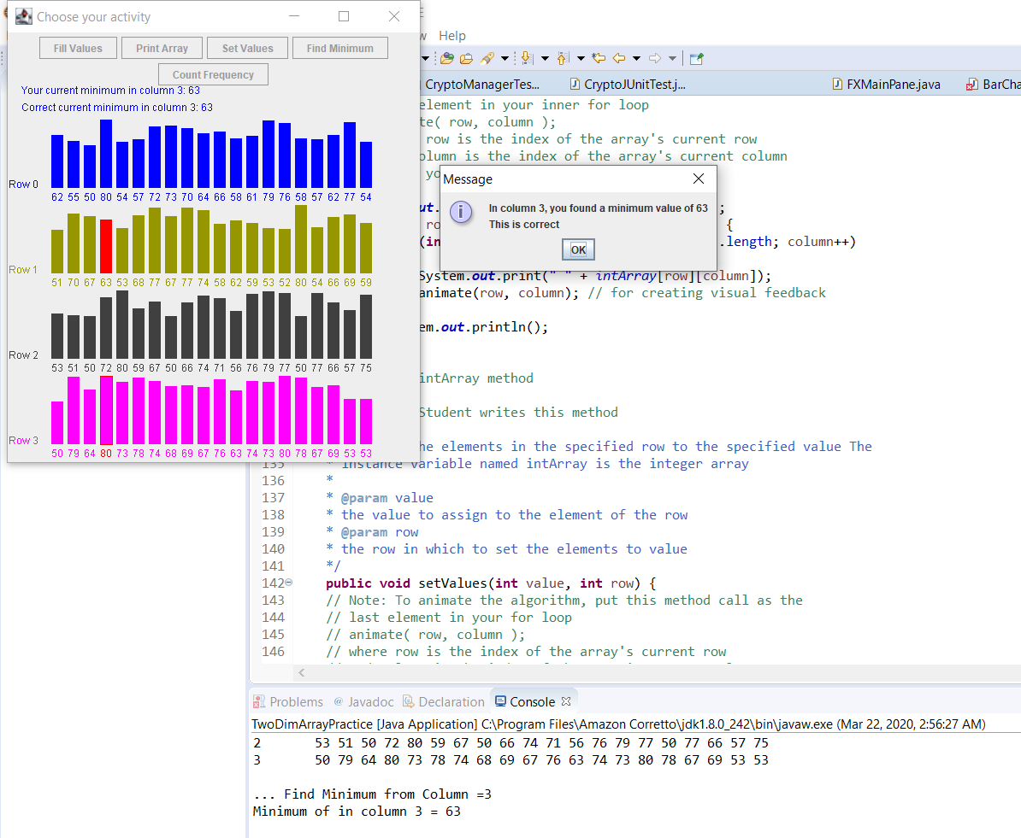

<https://github.com/Tevy-B/CMSC-WEEK-6-7-8>